HTML 18/04/2019

<https://www.keycdn.com/blog/chrome-devtools>

<https://tennguoidepnhat.net/>

1. ***In order to define charset for HTML5 Doctype, which notation should I use?***
2. **Short:**

<meta charset="utf-8" />

1. **Long:**

<meta http-equiv="Content-Type" content="text/html; charset=utf-8" />

1033

In HTML5, they are equivalent. Use the shorter one, it is easier to remember and type. [Browser support is fine](http://code.google.com/p/doctype-mirror/wiki/MetaCharsetAttribute) since it was designed for backwards compatibility.

245

Both forms of the [meta charset](http://www.w3schools.com/tags/att_meta_charset.asp) declaration are equivalent and should work the same across browsers. But, there are a few things you need to remember when declaring your web files character-set as UTF-8:

1. Save your file(s) in UTF-8 encoding *without* the [byte-order mark](http://www.w3.org/International/questions/qa-byte-order-mark) (BOM).
2. Declare the encoding in your HTML files using [meta charset](http://www.w3schools.com/tags/att_meta_charset.asp) (like above).
3. Your web server *must* serve your files, declaring the UTF-8 encoding in the Content-Type HTTP header.

Apache servers are configured to serve files in ISO-8859-1 by default, so you need to add the following line to your .htaccess file:

AddDefaultCharset UTF-8

This will configure Apache to serve your files declaring UTF-8 encoding in the Content-Type response header, but your files *must* be saved in UTF-8 (without BOM) to begin with.

Notepad cannot save your files in UTF-8 without the BOM. A free editor that can is [Notepad++](http://notepad-plus-plus.org/). On the program menu bar, select "Encoding > Encode in UTF-8 without BOM". You can also open files and re-save them in UTF-8 using "Encoding > Convert to UTF-8 without BOM".

More on the [Byte Order Mark (BOM) at Wikipedia](http://en.wikipedia.org/wiki/Byte_order_mark).

HOANGF THUY LINK : <https://stackoverflow.com/questions/4696499/meta-charset-utf-8-vs-meta-http-equiv-content-type>

1. ***Conditional Comment.***

Only in IE5 ( – IE9)

HOANGF THUY LINK : <https://www.sitepoint.com/internet-explorer-conditional-comments/>

1. ***Meta Tags:*** Empty Element, does not have a Closing Tag.

[HOANGF THUY LINK : https://www.tutorialspoint.com/html/html_meta_tags.htm](https://www.tutorialspoint.com/html/html_meta_tags.htm)

1. ***Viewport:*** Visual Viewport (khung nhìn trực quan) và Layout Viewport (khung nhìn bố cục).

HOANGF THUY LINK : <https://developer.mozilla.org/en-US/docs/Glossary/viewport>

1. ***Meta Tag <meta name=”viewport” content=”width=device-width, initial-scale=1”/>***

* The width property controls the size of the viewport. (Height). width=600,
* The initial-scale property (tỉ lệ gốc) controls the zoom level when the page is first loaded (được tải lần đầu), maximum-scale, minimum-scale, and user-scale.

HOANGF THUY LINK : <https://developer.mozilla.org/en-US/docs/Mozilla/Mobile/Viewport_meta_tag>

1. ***Meta <meta property=”og:type” content=”website”/> Open Graph*** → Thumbnail (hình thu nhỏ) → SEO.

HOANGF THUY LINK : <https://www.optimizesmart.com/how-to-use-open-graph-protocol/>

HOANGF THUY LINK : <https://cosmospham.wordpress.com/2013/01/20/open-graph-la-gi/>

HOANGF THUY LINK : <https://blog-xtraffic.pep.vn/nhung-social-meta-tags-quan-trong-nhat-ma-website-can-co/>

HOANGF THUY LINK : <https://seomoa.edu.vn/cach-thay-doi-meta-propertyoglocale-contenten_us>

1. ***Class***

.city {

Background-color: tomato;

}

→

<h2 class=”city”>Ha Moi</h2>

Multiple Classes

<h2 class=”city nation”>Ha Cu</h2>

Different Tags can share same class.

Using the Class Attribute on inline Elements.

span.note {

front-size: 120%;

color: red;

}

<h1>This is some <span class=”note”>important text.</span></h1>.

HOANGF THUY LINK : <https://www.w3schools.com/html/html_classes.asp>

HOANGF THUY LINK : <https://developer.mozilla.org/en-US/docs/Web/HTML/Global_attributes/class>

1. ***Chrome Dev Tools***

<https://developers.google.com/web/tools/chrome-devtools/>

1. ***<main> Element***

<article>, <aside>, <footer>, <header>, <nav>, <main>

<main> : chỉ dùng 1 lần trong 1 trang HTML, không làm con của <footer>, <header>, …

<https://www.w3.org/TR/html-main-element/>

<https://www.w3schools.com/tags/tag_main.asp>

<https://developer.mozilla.org/en-US/docs/Web/HTML/Element/main>

1. ***Semantic (HTML5)***

Semantics : các phần tử có ý nghĩa. Do HTML4, dev phải đặt theo id các Semantics. Qua HTML5, thống nhất các Semantics như main, footer : hàm chứa báo cho trình duyệt biết đây là phần tử nội dung (khác <p>, <div>).

<https://viblo.asia/p/semantic-html-va-mot-so-the-html-de-phan-chia-noi-dung-trang-ByEZk9k25Q0>

<http://fedu.vn/thu-vien-hoc-tap/lap-trinh-web/front-end/html5/cac-phan-tu-ngu-nghia-trong-html5/>

<https://developer.mozilla.org/en-US/docs/Glossary/Semantics>

1. ***Chuyển đổi từ HTML4 sang HTML5***

Chuyển từ HTML4 sang HTML5 :

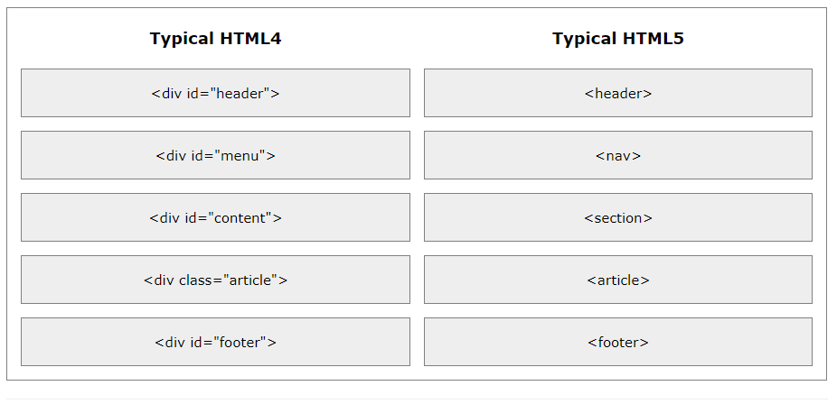

* <meta charset=”utf-8”/>

(<meta http-equiv=”Content-Type” content=”text/html;charset=utf-8”/>

* <!DOCTYPE html>

(<!DOCTYPE HTML PUBLIC “-//W3C//DTD HTML 4.01 Transitional//EN” “http://www.w3.org/TR/html4/loose.dtd”?>)

* CSS:

header, footer {

}

(div#header, div#footer {

})

<http://fedu.vn/thu-vien-hoc-tap/lap-trinh-web/front-end/html5/chuyen-tu-html4-sang-html5/>

1. ***Text Formatting***

Browsers display <strong> as <b>, and <em> as <i>. However, there is a difference in the meaning of these tags: <b> and <i> defines bold and italic text, but <strong> and <em> means that the text is IMPORTANT.

(Tại sao defines lại có s) (vì đi theo chủ ngữ thứ 2).

1. ***DISPLAY: Inline-Block***

<https://www.codehub.vn/Hieu-Cach-hien-Thi-Inline-Block-va-Inline-Block-trong-CSS>

<https://www.w3schools.com/css/css_inline-block.asp>

1.

<https://hocwebchuan.com/reference/cssSection/pr_display.php>

1.

<https://hocwebchuan.com/reference/cssSection/example/ex_display.php>

table: ngắt dòng trước và sau.

Ngắt dòng, nhưng width chỉ vừa vặn table, không như block.

1. ***Vấn đề thẻ <iframe>***

<http://itplus-academy.edu.vn/hiem-hoa-khon-luong-tu-the-iframe-ban-nen-tranh-2045.html>

Hình như <iframe > là thẻ trong HTML5, khác với <frame>, <frameset>

<iframe> : YOUTUBE nhúng vào web (20-30%).

SEO : Search Engine Optimize.

1. ***Thẻ trong HTML5***

<https://www.tutorialrepublic.com/html-reference/html5-tags.php>

Thẻ trong HTML5.

1. ***HTML4 Tags***

<https://www.quackit.com/html/html_4/tags/>

1. ***Về vấn đề float trong CSS***

Chú ý CSS: clear float.

<https://internetingishard.com/html-and-css/floats/#setup>

<http://web.simmons.edu/~grovesd/comm328/modules/layout/floats>

<https://developer.mozilla.org/en-US/docs/Learn/CSS/CSS_layout/Floats>

<https://thachpham.com/web-development/html-css/chia-cot-voi-float-va-clear-float.html>

<https://viblo.asia/p/ky-thuat-float-va-clear-trong-css-jvElaLnYZkw>

box-sizing: border-box; => thiết lập giá trị cố định cho 1 phần tử kiểu box: như div,… Dù có padding, margin hay không, thì vẫn y nguyên width và height.

Vùng chọn tất cả: *. SELECTOR.

* {

box-sizing: border-box;

-moz-box-sizing: border-box;

-webkit-box-sizing: border-box;

}

<https://thachpham.com/web-development/html-css/hoc-css-tim-hieu-box-sizing.html>

float: tức là trôi nổi (như gỗ), giải phóng vùng không gian, còn lại vùng hiển thị. VKG có thể bị xâm lấn khi float, nhưng vùng hiển thi thì không.

Tại sao trong div, float p1, p2, xong div còn 1 gạch. 🡪 Vì vùng không gian đã hoàn toàn mất hết, div bao bọc 1 cái hư không. Tuy vậy, vùng giá trị còn y nha.

CLEAR float:

<https://kipalog.com/posts/Co-the-ban-biet-roi--CSS-Floating-va-Clearfix>

clear: both, left, right, none.

Thường thêm 1 phần tử giả: ::after, hoặc tự thêm 1 div vào cuối. Nó sẽ tự kéo div cha theo height (có thể là do mất vùng không gian, nên div cha tự hiểu height: 0px; 🡪 xóa float, thì cần 1 div con giả, ẩn nó đi, thì TD tự hiểu còn vùng KG, nên đo xuống và tự thấy height).

Đúng như thế, div cha đo height, width của các vùng không gian còn được dùng, chưa float.

1. ***@media : trong responsive***

<https://hocwebchuan.com/reference/tag/html5/attr_media.php>

<https://freetuts.net/su-dung-media-css-tao-responsive-cho-website-660.html>

1. ***Phần tử AFTER + BEFORE***

<https://freetuts.net/after-va-before-trong-css-447.html>

1. ***Em, anh, nhầm, em vs rem***

* ***em = font-size của div.***
* ***rem = font-size trong thẻ html.***
* <https://thachpham.com/web-development/html-css/cac-don-vi-do-luong-trong-css.html>

1. ***sfdjcx***